

MBSS Parent Advisory Council Minutes
March 13th 2023 – 6.30pm

MBSS PAC Executive for 2022/2023
President: Melissa Ganzeveld Vice Present: Rebecca Ashley
Treasurer: Laura Sharun COPAC Rep: Olena Golulubuva
Member at Large: Wendy Sutherland

Call to order: 6.34pm

In Attendance: Melissa Ganzeveld, Rebecca Ashley, Deb Lozinsky, Wendy Sutherland, Melissa Reddekopp, Scott Sieben, Chantelle Desrosiers, Shannon

Approval of prior minutes from February 2023: Chantelle / Melissa R

Approval of today’s agenda: Rebecca / Wendy

Robotics Club Presentation: A wonderful display of robotics at the recent international tournament in Victoria. It was a pleasure to hear about the success of the event and congratulations to the MBSS Robotics Club for winning 2nd place!

Administration report: Attached as appendix A

Treasurer report: Attached as appendix B

CoPAC report: Attached as appendix C

Existing Business:

- Election of remaining executive MBSS PAC roles – Secretary – this role still remains open

- Dry Grad Committee update – Rebecca and Melissa
  - A cheque for $2,000 was presented to the MBSS Dry Grad committee from the MBSS PAC as approved in the 2023 budget

- Signing authority for the PAC account – on hold until a new treasurer is found

- PST update – Laura submitted on Nov 10th, we are still waiting for an approval

- Continued conversation – The PAC is requesting teachers present information regarding events, clubs and options at the school at the monthly PAC meeting.
  - Jim Elwood will present at the April PAC meeting on indigenous art

- Continued action on our fundraisers
  - Natures Fair –
    - The box is now in the reception, communication has launched and is ongoing with $175 raised so far, fantastic work!
  - Spring Photo Fundraiser update –
    - Dates confirmed with Lori – April 7th and 8th / April 29th and 30th / May 6th and 7th
    - Price increase - $125 with $40 to the PAC
    - Lori is working n the pasters for us now and we can start getting the word out
    - Location as of now is by the water at Gellatly Nut Farm
  - M&M Meats –
    - 15% kick back during the month of April – added to School Cash online and leadership groups getting the word out. PAC to get the word out on social media
    - 5% COBS Bread year round fundraiser – discussion with admin n the best way to get the word out around school. PAC to get the word out on social media
MBSS PAC Festival:
- Festival at the school on April 21st with proceeds to the MBSS PAC
- Scott still confirming lunch times to be used but current is 11am – 2pm
- Food - M&M meats BBQ with purchasing through School Cash Online that is already up and running with final orders allowed until April 10th
  - Scott looking to give our colour coded tickets to students dependent on order amounts so that its easier for the helpers at the BBQ tent
- Location will be on the field with electric access provided
- Teams and stalls in attendance –
  - M&M BBQ
  - MBSS Grad – Melissa R - scones
  - Athletics team – Jason Hudson – concession stand
    - 3 students at the BBQ tent
    - spreading awareness of the event
    - Helping to drive students and teachers to the event on the day
  - Jr Leadership class – Kevin Low – dunk tank
    - Music for the event
    - 3 students at the BBQ tent
    - Designing posters and spreading awareness of the event
    - Helping to drive students and teachers to the event on the day
  - Indigenous Learning Community – Mary Redfearn - beading, buttons and stickers
    - spreading awareness of the event
    - Helping to drive students and teachers to the event on the day
  - Resource Team – Laurie Campbell – jewelry
    - spreading awareness of the event
    - Helping to drive students and teachers to the event on the day
  - Entrepreneur students – 2 stalls – focus still unknown
    - 3 students at the BBQ tent
    - Designing posters and spreading awareness of the event
    - Helping to drive students and teachers to the event on the day
- PAC attendance to ensure the event runs smoothly – Chantelle / Wendy and Deb

New Business:

New Business arising from today’s meeting:
- April PAC meeting changed to Monday April 17th at 6.30pm in the library so that we can have one final meeting and push for the festival prior to it launching

Next meeting date:
- April 17th 2023 at 6.30pm in the MBSS library

Adjourned: 7.58pm

Appendix A –

- We are currently in the process of looking over students course verification forms and are making final timetable course selections. We are hoping to have our 'courses' selected for next year by the end of the week.
- Next year, we will be offering more English First Peoples courses at the grade 10,11, and 12 level next year. This will assist all of our students in making sure that they have met the graduation requirement for completing Indigenous Focused course.
- The Ministry of Education has not made a decision in determining whether Indigenous Art Studio 12 will be allowed as grad requirement as an Indigenous focused course. This course has been at Mount Boucherie for the last 18 years, and was originally 'vetted' through the Westbank First Nation and the Indigenous Education Council. The WFN Chief and Council have written a letter of support for this course to be considered as an Indigenous focused grad requirement.

- Our Leadership classes are having some Spirit activities this week, and then will be planning some bigger activities after Spring Break. We are looking at having a Mental Health Day on May 30th, with some major activities. We are in the process of booking a motivational speaker for June, as well, if the calendar can be coordinated.
- The Ministry of Education's Literacy & Numeracy Assessments are being scheduled to be written in April (for classes), and then in June for students still needing to write them. The Ministry's Student Satisfaction Survey will also be given to students in the coming weeks.
- Athletics and Extra-Curricular –
Sports seasons for Boys' & Girls' Rugby, Girls' Soccer, Ultimate Frisbee (Co-Ed sport), Golf, and Track & Field will start after Spring Break.
Band students will be travelling to Whistler and to Edmonton for festivals and a tour after Spring Break.
Our Drama program is currently rehearsing the play "Failure: A Love Story", which they will perform May 3rd-5th.
- The second Indigenous RCMP camp will be held at Mt. Boucherie from May 26-29, 2023.
-Run by some members of our local RCMP detachment, the camp, though targeted for students with Indigenous Ancestry, is open for all students. Students can get 4 Work Experience credits for participating.
- Spring Break is March 18th-April 2nd.
Easter is April 7th(Good Friday) – April 10th (Easter Monday)

Appendix B –
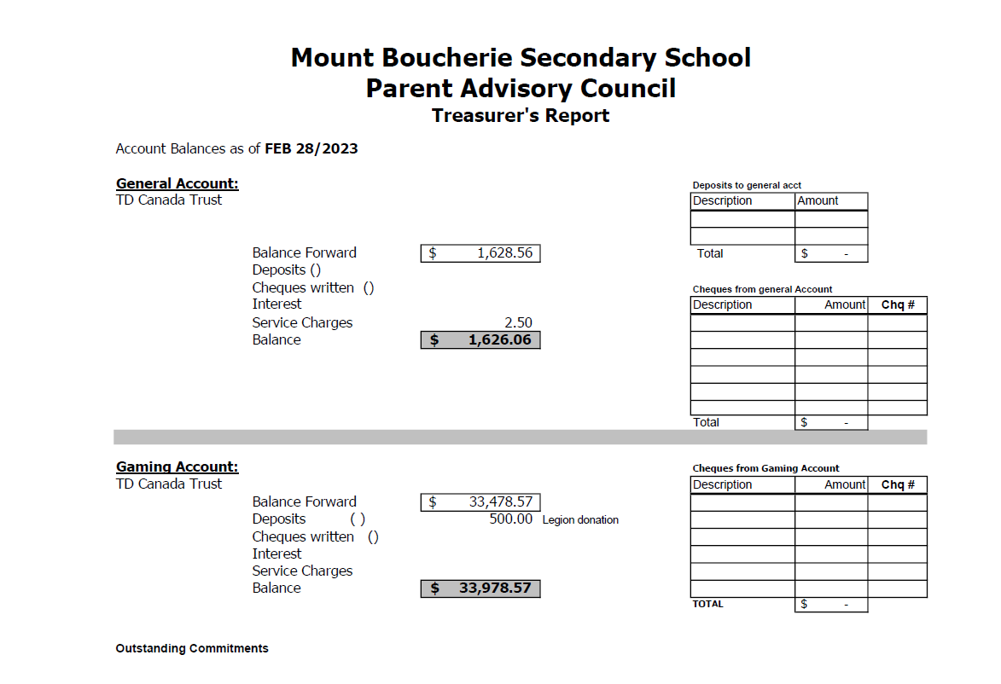

Appendix C –

- Call to Order: Greetings/Introductions- Simon Adams

2.0 Guest Speaker -No Guest Speaker this month

3.0 Establish Quorum (10 Voting Members) Established with 22 present

4.0 Agenda: Additions/Approval
Motion: To accept the February 6th, 2023, Agenda as presented.
Motioned by Jeannette W., seconded Roslyn H.
All in favour: Motion caried

5.0 Minutes: Additions/Approval
Motion: To accept the March 6th, 2023, Minutes as circulated.
Motioned by Nicola B., seconded Ryan L.
All in favour: Motion carried.

6.0 SD23 Partner Group Reports
Trustee Update – Chantelle Desrosiers
• Planning & Facilities Committee:
• Education & Student Services committee: Sexual Health Level 1 review- review on how the BC mandated Sexual Health curriculum is delivered by SD23 specialized teachers to students in grades 4-10 will be presented to this committee on April 19th.
• Finance & Audit Committee: Indigenous Education council sending their Budget recommendations to the board, board will also be looking at specialty academy fee increases as well as bussing fee increases.
Superintendent Update – Terry Lee Beaudry, Assistant Superintendent
• Student & Family Affordability Fund - Ensure the dollars are allocated where they are needed most supporting families challenged with finances. 63% of this budget has been spent on supporting students and families, more info will be coming forward at the April Finance & Audit committee.
• announcement of budget for our district will be around spring break
• Terry expressed gratitude to COPAC for reaching out to the Indigenous Education council to look at ways that COPAC can support the Indigenous Parent Family and Education Council (IPFEC). Simon and Nicola have been invited to attend the Indigenous Education council meeting in April. Due to COVID, IPFEC has remained dormant for a little over 2 years, looking to get Indigenous parents back involved in COPAC as well as running their own council.
CUPE- Teri Wishlow (newly elected CUPE President)
• Ad Campaigns promoting CUPE employees across the Okanagan. Photoshoots highlighting our diverse CUPE staff in our district, including Indigenous Advocates, custodial, CEA’s, clerical, Library Assistants, Bus drivers, and more. Looking forward to seeing our local faces, as quite often they are parents of students in our district, super proud of that and they are super proud of the job they do.
DSC- Zach Johnson
• Student Council is doing well and preparing for their upcoming March meeting.
COTA- Susan Bauhart
• teachers are busy preparing student learning updates (report cards),
• BCTF AGM upcoming over spring break.

7.0 PAC 360 (A quick opportunity for PACs to briefly discuss topics they may need assistance with from COPAC or SD23 or topics that might be relevant to other PACs – Simon Adams)
Question from Davidson Rd. Rep. Is there a resource out there that helps schools/ PACs to assist with finding what grants are available in our district? Re: Universally accessible playgrounds, Outdoor learning Classrooms, School community gardens -Nicola suggest to reach out to Watson Rd as they may have resource from their recent playground update. -Terry Beaudry says operations team have some UpToDate info about finding funding sources available. Reach out to Terry and can connect with a member of Operations team. -Nicola mentioned that Davidson Rd is number 7 on the SD23 Playground Priority plan see p.128 Appendix A - https://pub-sd23.escribemeetings.com/FileStream.ashx?DocumentId=784
-slack channel is another tool for communication, collaboration, sharing of knowledge for schools PAC Exec members. This is a free version and info is only available for 90 days.
-COPAC Executive has requested with operations department a resource for “PAC playground outdoor learning Road Map”

8.0 COPAC 360
• Motion: To accept the COPAC financial update as presented – Roslyn Hazen highlights MailChimp payment is listed under Presenter fee expense, Dan Duncan still payable Moved by Meagan R., seconded Shannon G..
All in favour: Motion carried.
• Notice of Motion: To amend the COPAC Bylaws – Nicola Baker
o Draft bylaw amendments will be circulated to PAC Presidents and COPAC reps. o COPAC Reps will vote on the amendments as a whole or individually at our next meeting on Monday, April 3rd.
• Call for Nominations for COPAC Executive – Camilla Biffard copacnominations2023@gmail.com o Nominations form is ready to be sent out, every position is up for nomination. Please share with your PAC Executive. You can nominate yourself or nominate someone else, minor requirements must be a parent with child in district and cannot be an employee of SD23.
• Notice of AGM - Nicola Baker
o May 1st to elect 2023/24 COPAC executive
• PAC’s Impact in Dollars – Simon Adams
o reminder that this survey was sent to 45 PACs, only 16 have replied, Out of these PACs we’ve discovered that $230,000 has been contributed towards our school district.
o If you haven’t completed survey please do so, your contribution to this survey will assist with our advocacy efforts.
• BCCPAC AGM– Nicola Baker
o Conference and AGM, if you can’t send a PAC rep you can assign your proxy vote to another SD23 PAC rep
o 6 different special resolutions to put forward at BCCPAC AGM, these have been created in collaboration with several DPACs with Surrey taking the lead.
o Increase to general meetings.
o Updates on Director and officers (mostly housekeeping)
o Duties of director and officers
o Policy to define the Job description of Directors.
o Posting meeting minutes and communication
o Update constitution
Nicola B. Motioned to put forth these resolutions with partner DPACs, seconded by Roslyn H.
All in favour: Motion carried. (To see the status of any Resolution, refer to the online Resolutions List & Archive.)
o COPAC to put forward resolution 2017.6 to reaffirm bump up on the list-Advocacy for the Capital Funding of Portables
Moved by Nicola B., seconded by Nicole C. All in favour: Motion carried.
Nicola will also be putting forward an ordinary resolution regarding Air Quality in schools
• Sexual Health Level 1 Review – Nicola Baker
o Anyone is welcome to attend the Education & Student Services committee meeting on April 19th.
• Specialty Academy Fees – Nicola Baker
o Reminder to PACs that according to the School Act, section 82.1, increases to these fees must be put forth to their school PAC and should be approved at a PAC meeting o Hardship clauses -Reminder from Trustee Chantelle Desrosiers, a student will not be excluded from any educational program due to financial hardship. This applies to specialty academies as well. Refer to School District Policy 425
• Parent Education & Communication Update – Deannie Z. & Shannon G. (see below for full report) o COPAC Social- Friday April 28th at 6:00 pm o ADHD Inside and Out with Dan Duncan –April 13 at 6:30 pm Please share this registration link with your PAC community.

9.0 Other Business - None

10.0 Adjournment –Nicola B. at 8:05pm
Future Meeting: COPAC General Meeting- Monday, April 3rd, 2023, 7:00pm via zoom.
District and Committee Meetings- Information is available on www.sd23.bc.ca
COPAC Website: http://copac.sd23.bc.ca
Facebook: https://www.facebook.com/sd23copac/ Twitter: @COPACSD23
Central Okanagan Parent Advisory Council General Meeting – March 6th, 2023 Update from Deannie Z. & Shannon G. (COPAC Members-at-Large, Parent Education & Communication Coordinators)
Deannie:
1. We are very excited that we had 23 PACs respond YES to hosting a COPAC Social. Please save the date for Friday April 28th. This will be for COPAC reps and PAC Presidents (or alternate exec member). It will be an informal get-together, to socialize, brainstorm advocacy, and enjoy some good eats. Registration will be required in order for us to order food and beverages. Please keep an eye out in your email the next few weeks for registration link to respond with who will be attending on behalf of your PAC.
Shannon: 2. Dan Duncan will present the ADHD Inside Out Framework on April 13 at 6:30 pm. This online learning opportunity will consist of a 45 min. presentation and Q&A period. Please share this registration link with your PAC community.
Deannie:
3. Just a friendly reminder that COPAC has funds for parent education opportunities that we need to spend annually. We need your help with ideas for parent education workshops, before booking and spending money on speakers please reach out to myself or Shannon so that we can look into bringing the speaker in to benefit our entire school district community.
4. We have posted information to the COPAC website on two provincial K to 12 guides that have recently come out by the government. Supporting Student Health guide and the K-12 Anti-Racism Action Plan. We encourage everyone to take a look at them and if you have any question please email Simon.
5. The quarterly newsletter will be sent out on Friday, please take a look and share info with your PAC membership.
6. Family Support Institute of BC offers monthly free Education Series. Tomorrow they will have a Zoom meeting at 6:30pm "Bumps in the Road: Problem Solving". Registration Event info shared to COPAC Facebook

