

MBSS Parent Advisory Council Minutes
February 27th 2023 – 6.30pm

MBSS PAC Executive for 2022/2023
President: Melissa Ganzeveld Vice Present: Rebecca Ashley
Treasurer: Laura Sharun COPAC Rep: Olena Golulubuva
Member at Large: Wendy Sutherland

Call to order: 6:34

Attendance review and welcome: Melissa G, Melissa R, Wendy S, Chantel D, Rebecca A

Approval of prior minutes from January 2023: MR/RA/ ALL

Approval of today’s agenda: Added to new business Treasurer request for supplies. CD/ WS/ALL

Administration report: Scott - See attached – appendix A

Treasurer report: General Account - just service charge transaction $1628; Gaming Account $33,478.57 – see attached appendix B
RA/WS/ALL

CoPAC report: No attendees this month. Attach noted from CoPac meeting – see attached appendix C

Existing Business:
- Election of remaining executive MBSS PAC roles – Treasurer, Secretary – we hope to have someone on board for September. Still need Secretary
- Dry Grad Committee update – Melissa R. Pub Night fundraiser coming up April 15 – need gaming license for 50/50. Looking for Silent Auction Items for Pub Night and t-shirt sponsors for Dry Grad night. Next Dry Grad meeting March 15th
PAC to provide approved donation
- Signing authority for the PAC account – on hold until a new treasurer is found
- PST update – Laura submitted on Nov 10th, we are still waiting for an approval
- Continued conversation – The PAC is requesting teachers present information regarding events, clubs and options at the school at the monthly PAC meeting.
  - Consideration of other presentations that might be provided with information valuable to families and students.
- Continued action on our fundraisers
  - Natures Fair – The box is now in the reception, communication has launched and is ongoing – how is this going? – Continual reminders to parents
  - Spring Photo Fundraiser update –
    - Lori is excited to return
    - Which 2 weekends to choose in April? - Looking at April 15/16 & May 13/14
    - Price increase - $125 with $40 to the PAC
  - M&M Meats – 15% kick back during the month of April – how best to get the word out? Asking everyone to share on FB & in neighborhood groups
Upcoming MBSS PAC Festival – April 21st
    - Food - M&M meats –
    - Location – front of the building
    - School Cash Online launched for BBQ orders with deadline of April 10th
    - MBSS PAC group attendance
      - M&M BBQ tent (student volunteers - 3 from entrepreneur group / 3 from athletics group)
      - PAC concession stand – Wendy
      - Entrepreneur students – 2 booths
      - Indigenous Leadership – 1 booth – Indigenous jewelry
      - MBSS athletics club – 1 booth
      - Band – 1 booth
    - Testing School “Square” for debit card use. May not work outside due to weak wifi
    - Staggered lunch hours to space out the numbers and manage crowds
New Business:
- New fundraiser – COBBS Bread – 5% kick back all year for anything purchased at the new West Kelowna location – Similar to M&M – get the word out with continual communication & sharing.
- Treasurer has had personal costs due to printing – PAC agreed to supply paper and replacement ink.

New Business arising from today’s meeting:

Next meeting date:
- March 13th 2023 at 6.30pm in the MBSS library

Adjourned: 7:50
Appendix A

1. Academy Fee Increases –
a. Golf Academy – Fee Increase from $150-$175 to $465 (With Course Membership) - $545 (Without Course Membership).
b. Hockey Canada Skills Academy – Fee Increase from $850 to $965.
c. Hairdressing Academy – Fee Increase from $850 to $950.
d. Mountain Biking Academy – Fee Increase from $265 to $325.
We are asking PAC to acknowledge that these courses will be presented to the Education & Student Services Committee, and then to our School Board Trustees for approval.

2. At present, our student projections for next year will be approximately 1725 students. This is a drop of over 75 students from the past year. However, we feel that because West Kelowna is growing at such a rapid rate, our student numbers will increase, as well.

3. We are currently in the process of course selection for next year. Courses will run provided that we have enough students for each class. We will be reviewing courses & student selections of courses in the weeks leading up to Spring Break to determine what courses will be in our timetable for next year.

4. One of our teachers, Mellissa Carroll, has been addressing our attendance problem, through the use of contracts and having a consequence for those students who are repeat violators. We have seen an improvement with some students getting to school more often and being on time for class, more often. However, many students are still absent or late for class without a good reason or excuse. We need assistance and support from parents.

5. Our Leadership classes had a busy time with Valentine's week a few weeks ago. We have a staff/student hockey game this Friday, and many more events will happen after Spring Break. (These students have also been 'cued' up to help on April 21st.

6. The Ministry of Education's Literacy & Numeracy Assessments are being scheduled to be written in April (for classes), and then in June for students still needing to write them. The Ministry's Student Satisfaction Survey will also be given to students in the coming weeks.

7. Our Dance Classes are hosted their Semester 1 final show at the Kelowna Community Theatre. They used our school theme for their Performance, "We Are All Works Of Art."
Feedback from the audience, staff, and students was extremely positive. A huge 'thank you' goes to our Dance Teacher, Maria Grant.

8. Athletics and Extra-Curricular –
Our basketball teams have all finished their seasons. The next sports which have started some initial practices are Boys' & Girls' Rugby, Girls' Soccer, Ultimate Frisbee (Co-Ed sport), and Track & Field.

Our Band program hosted GMS & CNB for our Westside Schools' Winter Performances on February 6th and 7th at the Kelowna Community Theatre. It was amazing to see the talent and passion that our students, and those at our Middle Schools, have. Band students will be travelling to Whistler and to Edmonton for festivals and a tour after Spring Break.

Our Drama program is currently rehearsing the play "Failure: A Love Story", which they will perform May 3rd-5th.

9. The second Indigenous RCMP camp will be held at Mt. Boucherie from May 26-29, 2023.
-Run by some members of our local RCMP detachment, the camp, though targeted for students with Indigenous Ancestry, is open for all students. Students can get 4 Work Experience credits for participating.

10. Spring Break is March 18th-April 2nd.
Easter is April 7th(Good Friday) – April 10th (Easter Monday)

Appendix B
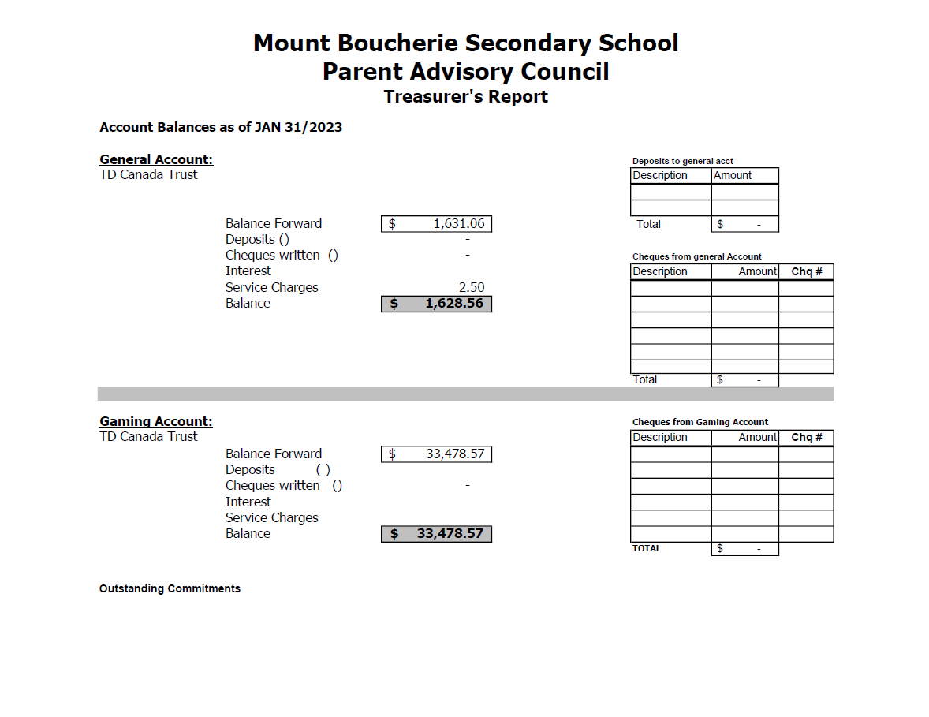

Appendix C

Simon Adams - President
Nicola Baker - Vice-President
Roslyn Hazen - Treasurer
Vacant - Secretary
Penny Liao-Lussier - Member At Large
Shannon Gallivan, Member At Large
Partner Groups
District Staff: Terry Beaudry, Deputy Superintendent
Delta Carmichael, Secretary Treasurer/CFO
Val Dougans, Kate Cumming
COTA: Susan Bauhart
CUPE: Teri Wishlow
DSC: Zach Johnson

SD23 Trustees:
Julia Fraser Amy Geistlinger Lisa Guderyan,
Wayne Broughton Val Johnson

Media: Barry Gerding, Black Press/Kelowna Capital News

1.0 Call to Order
Greetings/Introductions- Simon Adams

2.0 Guest Speaker
Delta Carmichael, SD23 Secretary Treasurer, and Kate Cumming, Assistant Secretary Treasurer – presented the background and high level summary for the draft 2023/2024 SD23 Budget.
• Central Okanagan Public Schools (SD 23) continues to increase in graduation rates over the past 6 years
• SD 23 has 96% graduation rate exceeding provincial average
• 4 Focused Directions for SD 23 2021-2026 Strategic Plan
(i) Equity & Excellent in Learning
(ii) System Wellbeing
(iii) Transformative Leadership
(iv) Family & Community Engagement

• SD 23 Funding driven by FTEs (full time equivalents) as defined as a student taking a full course load, and not by head counts as defined as how many employees/students in a building/a particular school
• SD 23 Serves 49 schools/sites
32 elementary
8 middle
1 alternate
3 learning centres
1 online learning (K-12)
• SD 23 Financial Income Sources – 3 Funds
1. Operating Budget – comprises of approx. 80% of budget (i.e. staffing)
2. Special Purpose (Targeted funding) Budget – comprises of approx. 18% of budget (i.e. Student & Family Affordability Funding). An additional Special Purpose funding received is the Classroom Enhancement Fund based on Supreme Court decision to assist SDs with implementation of the restored class size and composition limits
Special Purpose Funding for FY 2022/2023 = $37, 183, 158.00
Special Purpose Funding for FY 2021/2022 = $32,475,243.00
3. Capital Budget – comprises of 4% of total budget (i.e. building, equipment & vehicles)
**Overall budget approximately $302 million including 2022/2023 Previous Year Surplus of $4,221,323.00**
• Supplemental Funding Sources
Level 1, 2,3 students with unique needs generate supplemental funding from Ministry of
Education & Child Care (MECC). Trends seen in increasing student enrollment in SD 23 for
children with Autism
• SD 23 Financial Expenses Sources – Spending by Type
Employee Benefits = 17.6%
Supplies and Services = 10.3%
Capital & Other 1.9%
Salaries = 70.3%
Compared to similar SDs like Richmond, Abbotsford and Victoria, SD 23 spends less on
Administrative costs than other SDs
• Portables are not funded by the MECC. To purchase and install new portables costs the District approx. $350k/unit. To relocate and install a repurposed portable is $100k. District has 122 portables and expects to add 3 new portables and relocate 2 portables during 2023/2024 school year. Locations of portables (dependant on registration details) anticipated to be:
1 Mission
3 West Kelowna
1 Glenmore
• 2023-2024 Budget Considerations and Assumptions
*Projected student growth of 200 FTE next year
*MECC will fully fund BCTF & CUPE negotiated collective agreement grid increases Effective July 1, 2022
*MECC is funding a 4% increase for exempt, principals, and vice-principals effective July 1, 2022
*Additional teaching staff with student enrollment growth
*Teacher incremental grid increase
**MECC will announce funding for 2023/2034 budget in March 2023**
• Next Steps:

1. Get involved! Attend any or all public meetings (Finance and Audit and Public Board Meetings).

2. Provide feedback or ask questions at your school or the School Board Office

3. Provide feedback online via survey https://my.thoughtexchange.com/scroll/248429256/welcome

3.0 Establish Quorum
Quorum established

4.0 Agenda: Additions/Approval
• Motion: To accept the February 6th, 2023 COPAC Agenda as presented. Moved: Baker Second: Chidwick. Carried.

5.0 Minutes: Additions/Approval
• Motion: To accept the January 9th, 2023 minutes as amended. Moved: Liao-Lussier. Second: Roode. Carried.

6.0 SD23 Reports
Highlights of Partner Updates:
• Indigenous post-secondary credit course has been forwarded to MECC for approval.
• Sexual Health Education Level 1 review by SD23 is in process and results will be presented at the April Education & Student Services Committee Meeting.
• CUPE and SD23 have successfully concluded bargaining.
• Single/universal use washroom inventory was discussed at the January Planning & Facilities Committee. A motion to increase access will be forthcoming at the next Board Meeting.

7.0 PAC 360
A quick opportunity for PACs to briefly discuss topics they may need assistance with from COPAC or SD23 or topics that might be relevant to other PACs – Simon Adams

8.0 COPAC 360
• Motion: To accept the COPAC financial update as presented. Moved: Roode Second: Gallivan. Carried
• Motion: To name Camila Biffard as Chair of the COPAC Nominations Committee for COPAC Executive Nominees for the 2023/2024 school year. Moved: Baker Second: Codispoti. Carried
• Motion: On behalf of COPAC, send a letter of support of The Highway 97 Safe Traffic Flow Working Group. Moved: Hazen Second: Klim. Carried.
• Measuring Your PAC’s Impact in Dollars – PACs are reminded to complete the survey recently sent

measuring their financial impact on public education in SD23 https://forms.office.com/r/CXEvxsYsMK
• Nicola Baker made a Last Call For BCCPAC Resolutions.

9.0 Other Business

10.0 Motion to Adjourn: Codispotti

Future Meeting

COPAC General Meeting- Monday, March 6th, 2023 7:00pm via zoom.
District and Committee Meetings- Information is available on www.sd23.bc.ca
COPAC Website: http://copac.sd23.bc.ca
Facebook: https://www.facebook.com/sd23copac/
Twitter: @COPACSD23

