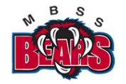

MBSS Parent Advisory Council Meeting Minutes
October 24th 2022

MBSS PAC Executive for 2022/2023
President: Melissa Ganzeveld Vice Present: Rebecca Ashley
Treasurer: Laura Sharun COPAC Rep: Olena Golulubuva
Member at Large: Wendy Sutherland

Call to order: 6.32pm

Attendance: Melissa Ganzeveld, Rebecca Ashley, Olena Golulubuva, Scott Sieben, Wendy Sutherland, Chantelle Desrosiers

Approval of prior minutes from October 2022: First Rebecca / Second Melissa

Approval of today’s agenda: First Chantelle / Second Wendy

Administration report: Attached as Appendix A

Treasurer report – yearend financial summary: Appendix B

CoPAC report: Attached as Appendix C

Existing Business:

- Election of remaining executive PAC roles – Treasurer / Secretary / Member at large
  - Wendy Sutherland nominated for member at large role – 2nd Chantelle / all in favour / carried

- Photo fundraiser for Fall – Waiting for final amount and funding to be sent to MBSS PAC – Melissa followed up

- Dry Grad Committee – The committee has started to meet and Rebecca is the MBSS PAC coordinator for the Dry Grad Committee and will be attending meetings moving forward

- MBSS PAC bank account signing updates – pushed to a future meeting once we have a new treasurer so that all signing authorities can be actioned and updated at the same time

- Bear tracks communication and parent contact – the MBSS PAC asked Principal Scott Sieben to bring bac the direct messaging of the Bear Tracks to the parents.

- PST rebate – Laura submitted the forms for the MBSS PAC PST rebate on Nov 10th and this and we are waiting to hear back.

- Rebecca advised she paid for the BCCPAC membership renewal approved at the last meeting

New Business:

- Letter from grad bursary thanking the MBSS PAC for their generous donation

- 2022/2023 school year teacher funding requests
  - Total allocation - $34,000
  - The teacher individual allocations can be seen in appendix D below
  - Melissa motioned to approve the 2022/2023 school year teacher funding requests of $34,590 based on the individual teacher allocation highlighted below in appendix D – 2nd Wendy – all in favour – carried

- Wendy and Melissa brought forward some wonderful ideas for fundraising this school year – we will discuss more as a PAC during the next meeting –
  - Natures Fair
  - 2nd photography session
  - M&M Meats

- A discussion was held on how to increase parent and guardian participation in the MBSS PAC meetings, suggestions revolved around –
  - Hybrid meetings of virtual and in person
  - Snacks and beverages
  - Guest speakers
It was asked that we continue this discussion during the next PAC meeting
Next meeting date:

- Nov 28th 2022 at 6.30pm in the MBSS library

Adjourned: 8.17pm

Appendix A – Administration Report

1. Scott Brown, one of our Vice Principals, is in the process of having his evaluation done. It started last year, but we had no parent responses in the survey from last June. We would like to have some parents respond to a survey that will be sent out soon.

2. COVID is still in our school. We do still have a few cases within our staff and have had a small number cases reported by parents of students, as well. However, reported cases have been relatively mild, compared to earlier cases.

3. Our office has been running 'short-handed' recently. We have had Admin off (right now, Ms. Owens will be off for the next 6 weeks), are short one clerical position, and have had our Accounts Clerk break her arm.

4. We have had Mya Ghostkeeper and Rowyn Tobin, 2 of our Indigenous students, had the opportunity to have a 'Question and Answer' period, via ZOOM, with the Honourable Murray Sinclair, the former Chair of Canada's Truth & Reconciliation Commission. (He has been selected to be the latest inductee to Mount Boucherie's "Hallway of Heroes."Also in attendance, were Scott Sieben, Principal of MBSS, Central Okanagan Public School's Superintendent Kevin Kaardal and Deputy Superintendent Terry Beaudry, and Jordan Coble, councillor for the Westbank First Nation.

5. Our Leadership classes continue to host events and plan activities to build school spirit for our school community.

6. Recently, Grads have been given a survey in regards to Grad events.

7. Ministry of Education Literacy & Numeracy Assessments will be held next week (Oct. 31st - Nov. 4th )

8. Athletics and Extra-Curricular activities are still on! Presently, we have Football, Volleyball, Cross Country, Boys Soccer, and Field Hockey. Drama has been holding auditions. The Band are preparing to play in Festivals etc., and some clubs have started.

9. Student Affordability Fund – on Friday, our School District sent out a memo in regards to the Student Affordability Fund. Parents must fill out the form through a link in the email memo. However, many items that are listed may not be approved by Mount Boucherie.

Appendix B – Treasurer report

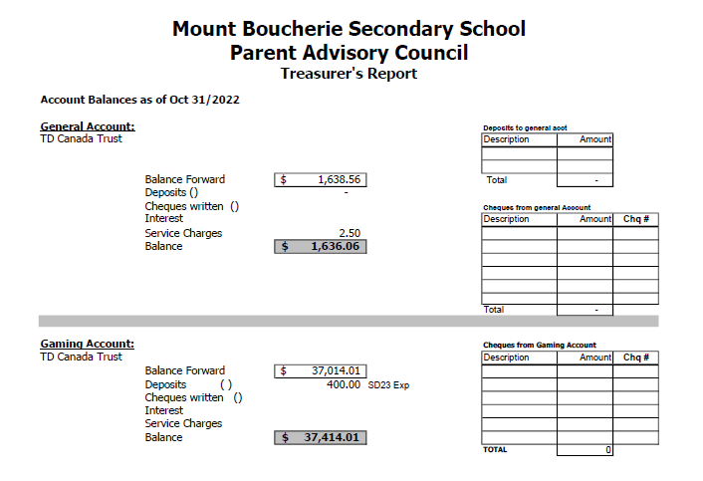

Appendix C – CoPAC minutes

- Guest Speaker Jordan Kleckner, SD23 Director of Instruction: Learning & Innovation:
This school year (22-23), a development team from across the province is supporting the Ministry of Education & Child Care in co-constructing supporting documents and resources for teachers, parents, and caregivers, to support BC's new Student Reporting Framework, set to be implemented in the 2023/24 school year. Jordan provided a detailed update on the draft Ministry Student Reporting Order and the timeline for its implementation, as well as provide an opportunity to gather feedback and input from all those in attendance.

- SD23 Reports
Deputy Superintendent Update:
• Swearing in Ceremony for new Trustees on Wednesday, November 9, 2022
• Indigenous Veterans Day – increase in uptake within district to honor Indigenous Veterans as veterans lost their Indigenous “Status” when they enlisted in the past

- Student & Family Affordability Fund – SD 23 have actively supported initiative through the following examples:

1. Number of parents have asked to have various school fees waived through direct application process & hundreds of thousands of dollars have been waived already
2. Funding set aside to purchase gift cards to support families during Christmas months.
3. Expanded brown bag lunches program and weekend backpack program for families experiencing food insecurity
4. Additional supports provided for Indigenous & newcomer families
5. Waived cultural fees and school supplies fees for select schools based on need
• Delta Carmichael – SD 23 Secretary Treasurer currently working through process to explore funding for all hot lunch programs with Student & Family Affordability Fund to lessen burden of costs for district PACs

- COTA:
BCTF has arrived at a tentative agreement; ratification vote on November 28th, 29th and 30th for teachers

- PAC 360
• A quick opportunity for PACs to briefly discuss topics they may need assistance with from COPAC or SD23 or topics that might be relevant to other PACs – Simon Adams
• Affordability Fund Feedback

- COPAC 360
• Simon Adams reported 60% increase in votes for this year’s Trustee voting versus previous year – over 200 people in attendance during All Candidates Forum -over 1000 views of YouTube video for All Candidates Forum. COPAC extends thanks to District Student Council for co-hosting the event and to all 2022 Trustee Candidates who participated.
• Motion: To approve the COPAC financial statements as presented. Motion passed.
• Shannon Gallivan and Deannie Zahara shared the following COPAC Education Plan for the 22/23 year: o Creation of a PAC Directory of Learning Opportunities – A COPAC curated series of opportunities that PACs can access and share with their parent communities based on their needs (i.e. Partners in Inclusive Education)
o Learning opportunities shared via COPAC Newsletter and Socials
o COPAC Workshop and Engagement Series – (i.e. hot lunches, bylaws, PAC listening tours, Learning What Our Kids Are Learning workshop)
o 1-2 Signature Events – TBD

• Nicola Baker shared from the Education & Student Services Committee that some Board authorized courses will be put forward to the Ministry of Education & Child Care for approval as it relates to the new Ministry of Education Indigenous Course Credit requirements. If Ministry approved, there is a possibility that retroactive course credits may be granted for recognized courses taken in the 21/22 school year. COPAC will provide an update as soon as it is available.
• Nicola Baker shared that Elementary PACs might consider summer literacy programs and reach out to their admin teams in early 2023 to discuss options in their family of schools.

Appendix D - 2022/2023 school year teacher funding requests approved

- Administration – camera system - $6,500
- Grad – 200 new gowns - $4,000
- Athletics – uniform and equipment replacement - $4,000
- Drama – Soundboard - $1,500
- Band – Music festival - $4,590
- Robotics – kits and competition - $6,000
- Leadership – school event supplies - $4,000
- School enhancement – courtyard improvements - $4,000
  - Total $34,590

All funding requests submitted and PAC discussion on priority level

