

MBSS Parent Advisory Meeting Minutes
Dec 12th 2022 – 6.30pm

MBSS PAC Executive for 2022/2023
President: Melissa Ganzeveld Vice Present: Rebecca Ashley
Treasurer: Laura Sharun COPAC Rep: Olena Golulubuva
Member at Large: Wendy Sutherland

Call to order: 6:35 pm

Attendance: Rebecca Ashley, Dalavanh Collins, Chantelle Desrosiers, Melissa Ganzeveld, Choncharee Phaugathunar, Wendy Sutherland

Approval of prior minutes from October 2022: First Chantelle / Second Wendy

Approval of today’s agenda: First Rebecca / Second Dalavanh

Administration report: Attached as Appendix A

Treasurer report: Attached as appendix B
Balances for the period ending November 7, 2022.
- General account $1,636.06
- Gaming account $37,414.01

CoPAC report: Attached as Appendix C
- Reminder that parents and guardians can sign up for the COPAC newsletter if interested.

Existing Business:
- Executive MBSS PAC roles for Treasurer and Secretary remain open
- Photo Fundraiser had 59 families participate and raised a total of $1,770
- Changes to signing authority for the PAC account is put on hold until executive positions are filled.
- PST rebate was submitted on Nov 10th by Laura
- Bear tracks communication will be emailed to parents beginning in January.
- Future fundraiser ideas
  - Natures Fair – Have not heard back from them with package yet. Wendy will be spearheading.
  - Will try to book a 2nd photography session in the Spring, preferably the first two weekends in April.
  - M&M Meats – During April, if customers mention MBSS at time of purchase 15% of purchase will be donated to the MBSS PAC. Also, M&M Meat will put on a BBQ at the school on April 21st with all profits going to the MBSS PAC

New Business arising from today’s meeting:
- Inquiry whether teachers might be able to present information regarding events, clubs and options at the school. Consideration of other presentations that might be provided with information valuable to families and students.

Next meeting date: Jan 23rd 2023 at 6.30pm in the MBSS library.

Adjourned: 7:54

Appendix A – Administration Report

- We have had an 'unsettled' year in the office, with lots of our admin and secretarial team off for a variety of sicknesses etc. As mentioned at our last PAC meeting, Scott Brown, one of our Vice Principals, is in the process of having his evaluation done. It started last year, but we had no parent responses in the survey from last June. We would like to have some parents respond to a survey that will be sent out in January. Right now, we are missing a MyEd secretary, and Ms. O'Brien is away on a leave, as is VP Ms. Owens. Mr. Miller, assisting with VP duties, (and before him, former MBSS VP, Ms. Weninger,) and Ms. Potter, assisting with clerical duties, have been in to work in the office during the last few weeks or so. Both Ms. O'Brien & Ms. Owens are expected back in January, and Ms. Sekhon will join us as our new MyEd clerical person in January, as well.

- We are presently working with Westbank First Nation on a Local Education Agreement for our School District. We are looking to continue to improve communication and develop a success plan for all of our vulnerable learners.

- Our Leadership classes continue to host lots of events and plan activities to build school spirit for our school community. During December, they are organizing and running the 12 Days of Christmas, with events every lunch hour. (Staff vs Student events (trivia, sports etc.), Spirit Wear, Gingerbread house building, movies, 'Just Dance' competition, Bingo, 'Gladiator' games, Winter Market, Photos with Santa, Pancake Breakfast etc.)

- Recently, some of our Grads, (the ones with an English 12 this semester), completed their Capstone Presentations on Wednesday Dec.7th. As part of the celebration, we hosted the Winter Formal dance that evening. As well, we have hosted another Grad Assembly as we start to prepare for Graduation 2022, and get the word out about grad events.

- Athletics and Extra-Curricular –
- Our Band program will play a JAZZ Night at GMS On Wednesday night, starting at 6:00pm, and will keep preparing for Festivals etc. in the New Year.
- Presently, we have Basketball teams playing at all levels in tournament and league play, and our grade 9 Boys hosted their first tournament this past weekend.
- Our Sr. Boys will host their annual Alumni Tournament this Friday & Saturday, and will host the first Westside Classic Tournament on January 12-14. This is the first time we are hosting a Sr. Tournament in quite a few years. We are hoping to grow the tournament every year, and are looking for sponsorship.
- Also, scorekeepers are needed for Basketball – we pay students to scorekeep!
- Our Football team made the BC play-offs, and our Sr. Girls Volleyball team won the City Championships and then came second in the province for the first time. It was a MBSS & OKM Provincial Final – the first time ever, in any sport, that two Central Okanagan teams met in the Provincial Final.

- Mount Boucherie hosted Cyber Expert Paul Davis who spoke to parents about some of the dangers of Social Media and the Internet for students and their families. We wish every parent and student could listen to his presentation.

Appendix B – Treasurer Report


  !"
#""$
% &'! "() )
"%* !)
)"+!$
))!+,%! !
%-. -/'! (
-/!-- %!( 0" "
-'&&( -% 1- %! 
!$%"!!$'-
/'2-/!3)$+ -&$!
4!-.)+ !

  !"
#""$
% &'! "() )
"%* !)
)"+!$
))!+,%! !
%-. -/'! (
-/!-- %!( 0" "
-'&&( -% 1- %! 
!$%"!!$'-
/'2-/!3)$+ -&$!
4!-.)+ !
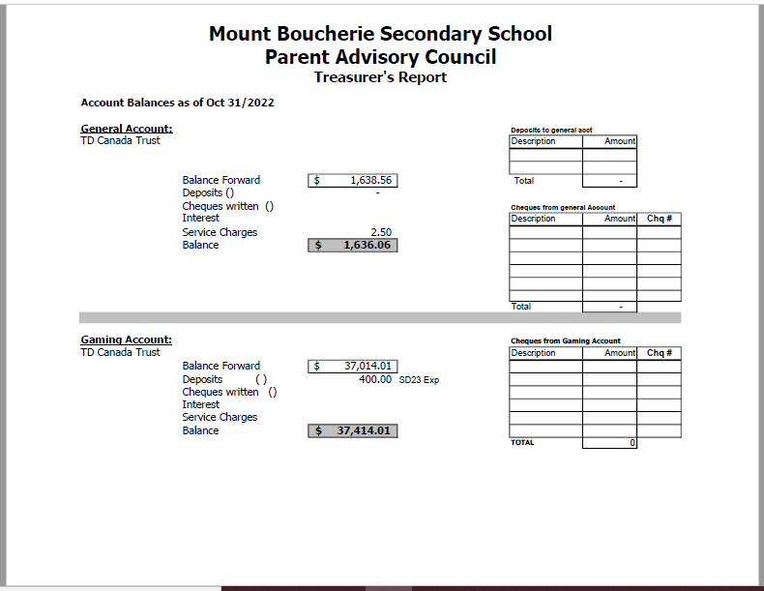

Appendix C – COPAC Report

The Central Okanagan Parent Advisory Council Minutes: General Meeting
Date: December 5th, 2022 at 7pm

COPAC Executive:
Simon Adams - President
Nicola Baker - Vice-President
Roslyn Hazen - Treasurer
Deannie Zahara, Member At Large
Shannon Gallivan, Member At Large

Partner Groups
District Staff: Kevin Kaardal, Superintendent
Terry Beaudry, Deputy Superintendent
COTA: Mary Hope
CUPE: Terry Wishlow, Simone Gauthier
DSC: Zach Johnson
SD23 Trustees:
Lee-Ann Tiede
Chantelle Desrosiers
Wayne Broughton
Valene Johnson
Amy Geistlinger
Lisa Guderyan
Julia Fraser

Guest Speakers
We were pleased to host all SD23 Board Trustees for introductions and discussion on new assignments for Trustee School Representatives. Superintendent Kaardal provided an overview of Trustee Liaisons in SD23 and directed COPAC Reps to the SD23 Board Website for a complete list of Trustees and associated schools. Each school in SD23 is designated a Trustee liaison. PACs are encouraged to involve and invite their Trustee reps to any of your events or for discussion (Trustees may not invite themselves). Principals are the first point of contact for SD23 queries and can assist with invitations to Trustees.
Deputy Superintendent Update:
• Indigenous and BC resident graduation rates have increased
• Parent excused student absences and staff absences have increased slightly over traditional
averages. Parents are encouraged to keep students home if they are not well.

PAC 360
• PACs are reminded to consider bringing school issues relevant to your school community to COPAC at regular general meetings or offline with the COPAC executive. PACs can contact COPAC at any time at copac.president@sd23.bc.ca
• Indigenous courses graduation requirements were discussed. Deputy Superintendent Beaudry will be visiting RSS, KSS and MBSS in January to discuss with parents. COPAC encourages OKM & GESS PAC to connect with Deputy Superintendent Beaudry on this issue.
• Corporate donations to PACs were discussed. Charitable tax receipts are possible when a donation is directed to SD23, however, PACs cannot issue tax receipts. Please reach out to COPAC if you have any questions.

COPAC 360
• Motion: To approve the COPAC financial statements as presented. Motion passed.
• Notice of Motion: Nicola Baker provided a notice of future motion to authorize the COPAC Executive to formalize collaborative work with other District Parent Advisory Councils (DPAC Coalition) in BC on advocacy issues not covered by BCCPAC.
• SD23 Board of Trustee meetings are being broadcast via zoom. Zoom links can be found at https://pub-sd23.escribemeetings.com/
• Reminder to school communities to report absences due to illness as an “illness” opposed to parent excused absence
• There are a number of walk-in community flu clinics available to students through public health. Check Interior Health Website.
• Please inform COPAC of any guest speakers PACs might like to hear from at future COPAC meetings

